
Department of Data Science
ALGORITHMIC PROBLEM-SOLVING HACKATHON (APSH 2026)
PROJECT DOCUMENTATION
Date: 03-10-2026 | Venue: 1st Floor, A & B Blocks
Field | Details
Project Title | SMART INVENTORY MANAGMENT
Team Name / Team No. | 17
Year / Semester / Section | II Year B.Tech / _1__ Sem / 1___
Algorithm Paradigm Used | Greedy / Divide & Conquer / Dynamic Programming / Backtracking / Branch & Bound / Graph
Programming Language / Tools | PYTHON
Faculty Mentor | SHESHIREKHA
Team Members
S.No | Name of the Student | Roll No. | Role
1 | R.RUPASRI | 25MVCSDR0158 | Team Lead
2 | G.ROOPIKA ISHWARYA | 25MVCSDR0159
3 | R.SUGUNA | 25MVCSDR0160
4 | S.LOHITH | 25MVCSDR0161

1. Problem Statement
State the problem clearly, with its inputs, outputs and constraints.

To select products to stock under limited storage capacity while maximizing the expected benefit.
Inputs :
- Number of products
- Product name
Outputs:
- Selected products to stock
- Total storage used
Constraints:
- Each product can be selected only once (0 or 1).
- Total storage used cannot exceed the available capacity.

2. Objectives

Optimize inventory selection by identifying which products should be stocked within limited storage capacity.
Maximize business value by prioritizing products based on their expected demand, importance, or benefit.

List 2–4 specific objectives of the project.

3. Proposed Approach
Explain the algorithm design paradigm chosen and why it suits this problem. Mention alternatives considered.

Algorithm Paradigm: Dynamic Programming (DP)
Approach: Use the 0/1 Knapsack algorithm to select products that maximize expected benefit without exceeding the available storage capacity.
Why DP suits the problem: The problem has overlapping subproblems and optimal substructure. DP avoids repeatedly solving the same smaller problems and efficiently finds the optimal product combination.
Alternatives considered:
- Brute Force: Checks every possible combination, but has O(2ⁿ) time complexity.
- Greedy: Faster, but does not always guarantee the optimal solution for 0/1 Knapsack.
Proposed solution: Dynamic Programming with O(nW) time and O(nW) space complexity.

4. Algorithm / Pseudocode
Write the step-by-step algorithm or pseudocode. Add a flowchart if needed.

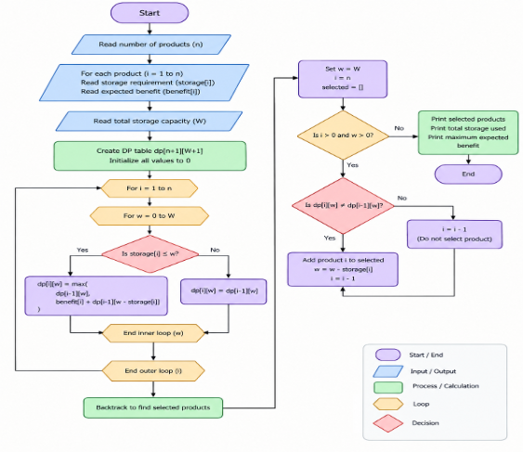

5. Complexity Analysis
Give the time and space complexity, with justification.
Complexity | Best Case | Average Case | Worst Case
Time | O(nW) | O(nW) | O(nW)
Space | O(nW) | O(nW) | O(nW)
6. Implementation
Describe the main modules or functions, the data structures used and the tools or platform.

To establish this project we used few resources such as:
- Python - to write and implement code using the 0/1 Knapsack Problem
- Visual Studio Code- The actual Python code was written here as it hosts the code to be able to run as well.
- VS Code Integrated terminal - Used to provide inputs and test the program.
- GitHub- Repository used to host the code so that multiple people can access it.
- Dynamic Programming - Algorithm design technique used to solve the optimization problem.

7. Results and Test Cases
Give sample inputs and outputs and attach screenshots. Compare performance with a naive approach, if applicable.

Approach | Time Complexity | Description
Naive / Brute Force | O(2ⁿ) | Checks every possible combination of products
Dynamic Programming | O(nW) | Stores results of smaller subproblems in a DP table

8. Conclusion and Future Scope
Summarise the outcome and the improvements possible.

Outcomes
- Successfully identifies the optimal combination of products within limited storage capacity.
- Maximizes expected benefit while ensuring the storage limit is not exceeded.
- Demonstrates how 0/1 Knapsack with Dynamic Programming can be applied to real-world inventory management.
- Provides an interactive system where users can enter product details and receive the optimal inventory selection.
Possible Improvements
- Add a database to store and manage product information.
- Include real-time factors such as product demand, sales trends, and stock levels.
- Add a user-friendly web/mobile interface instead of terminal-based input.
- Support multiple warehouses or storage locations with different capacities.
- Add data visualization and reports to help users understand inventory decisions.
- Incorporate real-world constraints, such as product expiration dates, minimum stock requirements, and changing product demand.

9. References
List textbooks, research papers and online resources (IEEE format).

[1] E. A. Goncalves de Souza, T. Mlinar, M. Van den Broeke, and S. Creemers, “Dynamic programming in inventory management: A review,” Computers & Operations Research, vol. 183, Art. no. 107164, 2025, doi: 10.1016/j.cor.2025.107164.
[2] M. Demaine, J. Ku, and J. Solomon, “Introduction to Algorithms: 6.006,” Massachusetts Institute of Technology, MIT OpenCourseWare, 2020.
[3] T. H. Cormen, C. E. Leiserson, R. L. Rivest, and C. Stein, Introduction to Algorithms, 3rd ed. Cambridge, MA, USA: MIT Press, 2009.
[4] Python Software Foundation, “The Python Tutorial,” Python Documentation. [Online]. Available: Python Documentation.

